GSEA Analysis Summary for Acromegaly

Significance was set at an alpha of 0.25 for BH adjusted p-values as calculated by GSEA. For the example gene sets, the gene in brackets is where the beginning of the core genes (the ones which most strongly impact that phenotype).

# Gene Ontology (BP)

## Upregulated in Acromegaly

None

## Downregulated in Acromegaly

None

# Gene Ontology (MF)

## Upregulated in Acromegaly

None

## Downregulated in Acromegaly

None

# KEGG

## Upregulated in Acromegaly

|  |  |  |  |  |  |
| --- | --- | --- | --- | --- | --- |
| Pathway | SIZE | ES | NES | NOM p-val | FDR q-val |
| KEGG_CITRATE_CYCLE_TCA_CYCLE | 30 | -0.7611927 | -1.9728404 | 0 | 0.001363636 |
| KEGG_PROPANOATE_METABOLISM | 32 | -0.70254177 | -1.8561193 | 0 | 0.009111926 |
| KEGG_VALINE_LEUCINE_AND_ISOLEUCINE_DEGRADATION | 44 | -0.6405129 | -1.7549288 | 0 | 0.030098855 |
| KEGG_FATTY_ACID_METABOLISM | 42 | -0.6060434 | -1.6564779 | 0.003076923 | 0.03879085 |
| KEGG_PEROXISOME | 78 | -0.55394703 | -1.7046679 | 0 | 0.039754175 |
| KEGG_BIOSYNTHESIS_OF_UNSATURATED_FATTY_ACIDS | 22 | -0.6982619 | -1.6618421 | 0.014164306 | 0.045033284 |
| KEGG_STEROID_BIOSYNTHESIS | 16 | -0.7209581 | -1.5974071 | 0.015075377 | 0.0577314 |
| KEGG_PPAR_SIGNALING_PATHWAY | 69 | -0.49728936 | -1.5156106 | 0.009230769 | 0.10286768 |
| KEGG_BUTANOATE_METABOLISM | 34 | -0.5546332 | -1.4874629 | 0.026954178 | 0.11189534 |
| KEGG_PYRUVATE_METABOLISM | 39 | -0.51466024 | -1.401081 | 0.027355623 | 0.17994899 |
| KEGG_TERPENOID_BACKBONE_BIOSYNTHESIS | 15 | -0.64195824 | -1.4094508 | 0.07455013 | 0.18577512 |
| KEGG_GLYOXYLATE_AND_DICARBOXYLATE_METABOLISM | 16 | -0.6116382 | -1.366153 | 0.0959596 | 0.21099563 |
| KEGG_PROXIMAL_TUBULE_BICARBONATE_RECLAMATION | 23 | -0.5456981 | -1.3206468 | 0.118644066 | 0.24991253 |

### Citrate Cycle (SDHA)

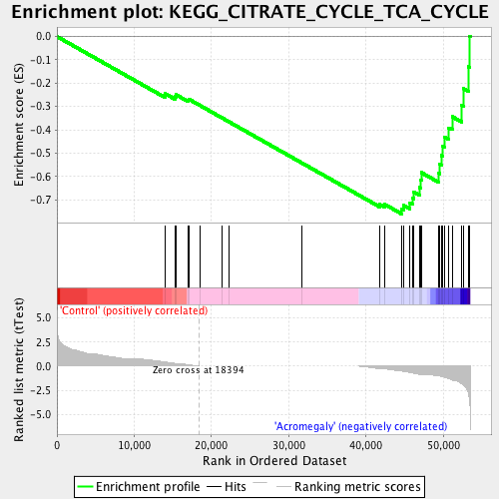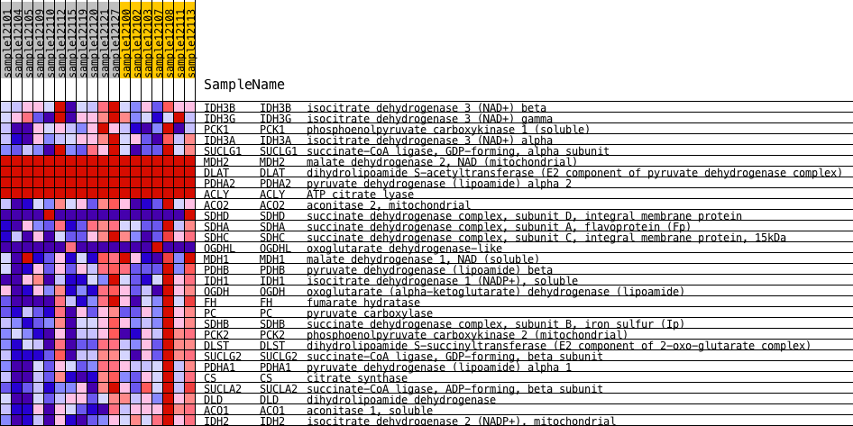

### Fatty Acid Metabolism (ACSL4)

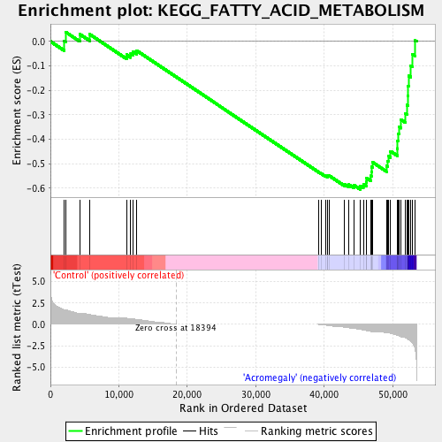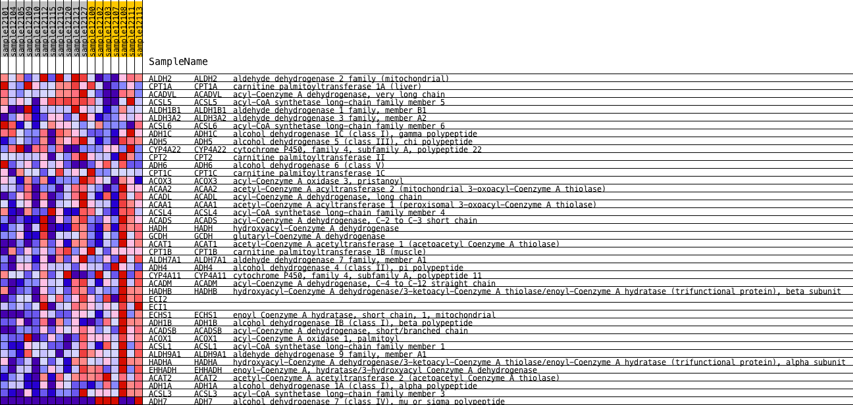

### Steroid Biosynthesis

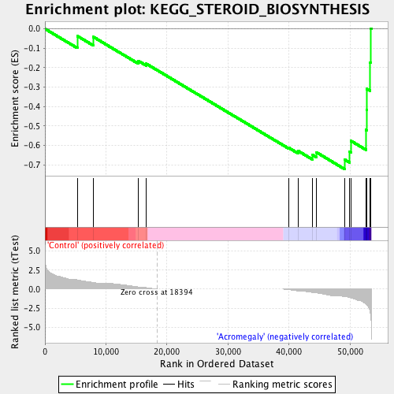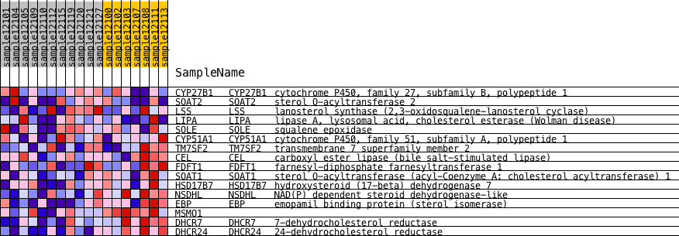

### PPAR Signaling (ACSL4)

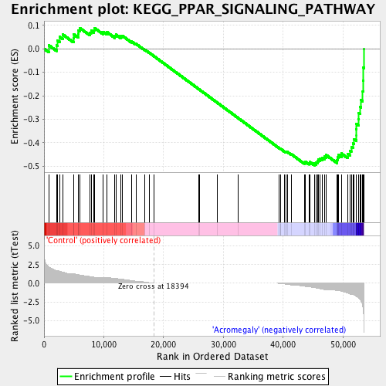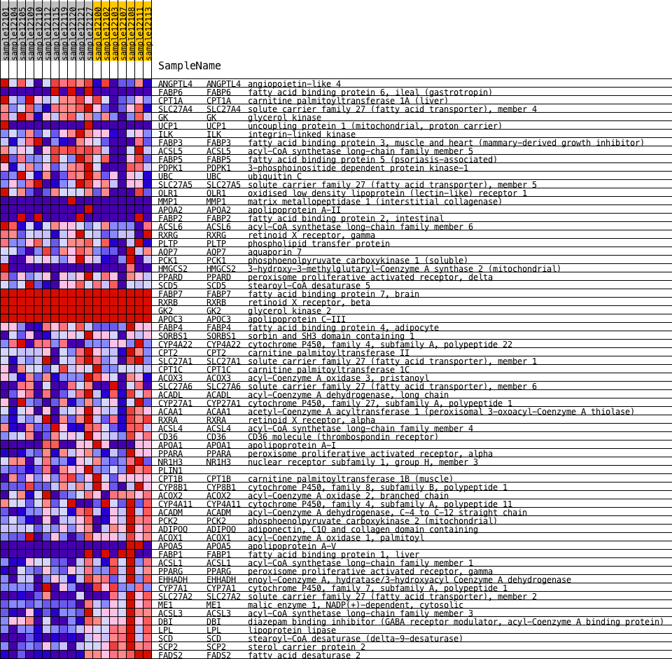

## Downregulated in Acromegaly

|  |  |  |  |  |  |
| --- | --- | --- | --- | --- | --- |
| Pathway | SIZE | ES | NES | NOM p-val | FDR q-val |
| KEGG_PATHOGENIC_ESCHERICHIA_COLI_INFECTION | 56 | 0.6491572 | 1.7126645 | 0 | 0.05628421 |
| KEGG_CHEMOKINE_SIGNALING_PATHWAY | 189 | 0.52829546 | 1.6230069 | 0 | 0.08772151 |
| KEGG_COMPLEMENT_AND_COAGULATION_CASCADES | 69 | 0.596523 | 1.6347167 | 0.001443001 | 0.10386536 |
| KEGG_TASTE_TRANSDUCTION | 50 | 0.5906472 | 1.5127466 | 0.015060241 | 0.124807574 |
| KEGG_HEMATOPOIETIC_CELL_LINEAGE | 87 | 0.5371428 | 1.5246742 | 0.00286123 | 0.13929474 |
| KEGG_CYTOKINE_CYTOKINE_RECEPTOR_INTERACTION | 261 | 0.47486284 | 1.5129193 | 0.00120919 | 0.14017753 |
| KEGG_LYSOSOME | 119 | 0.5218172 | 1.5342332 | 0 | 0.1419644 |
| KEGG_NOTCH_SIGNALING_PATHWAY | 47 | 0.5687546 | 1.4708331 | 0.01875902 | 0.14608255 |
| KEGG_ANTIGEN_PROCESSING_AND_PRESENTATION | 85 | 0.52326035 | 1.4782809 | 0.011220196 | 0.1478672 |
| KEGG_NATURAL_KILLER_CELL_MEDIATED_CYTOTOXICITY | 134 | 0.5230677 | 1.5413047 | 0 | 0.15322487 |
| KEGG_CYTOSOLIC_DNA_SENSING_PATHWAY | 56 | 0.55500984 | 1.4800134 | 0.003072197 | 0.16003819 |
| KEGG_PRIMARY_IMMUNODEFICIENCY | 35 | 0.5872793 | 1.4436392 | 0.029673591 | 0.18181059 |
| KEGG_T_CELL_RECEPTOR_SIGNALING_PATHWAY | 107 | 0.49188015 | 1.4347633 | 0.005540166 | 0.18348075 |
| KEGG_RIBOSOME | 88 | 0.54439074 | 1.5418881 | 0.001392758 | 0.19057812 |
| KEGG_INTESTINAL_IMMUNE_NETWORK_FOR_IGA_PRODUCTION | 48 | 0.54560924 | 1.4226696 | 0.03250774 | 0.19340667 |
| KEGG_VIRAL_MYOCARDITIS | 70 | 0.50238067 | 1.38732 | 0.026647966 | 0.20341666 |
| KEGG_TOLL_LIKE_RECEPTOR_SIGNALING_PATHWAY | 102 | 0.48017532 | 1.3913628 | 0.015789473 | 0.20520444 |
| KEGG_PROTEASOME | 45 | 0.5460446 | 1.3960799 | 0.03549383 | 0.20684254 |
| KEGG_LEISHMANIA_INFECTION | 72 | 0.51668686 | 1.4012538 | 0.009985735 | 0.21047549 |
| KEGG_GLYCOSAMINOGLYCAN_BIOSYNTHESIS_CHONDROITIN_SULFATE | 22 | 0.6344608 | 1.4045918 | 0.04825291 | 0.21595052 |
| KEGG_DILATED_CARDIOMYOPATHY | 90 | 0.48259315 | 1.3681754 | 0.022727273 | 0.23031262 |
| KEGG_REGULATION_OF_ACTIN_CYTOSKELETON | 212 | 0.43880373 | 1.3589908 | 0.008454106 | 0.23979829 |

### Chemokine (Until STAT5B)

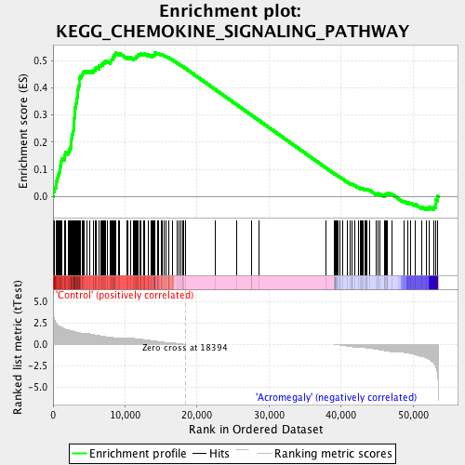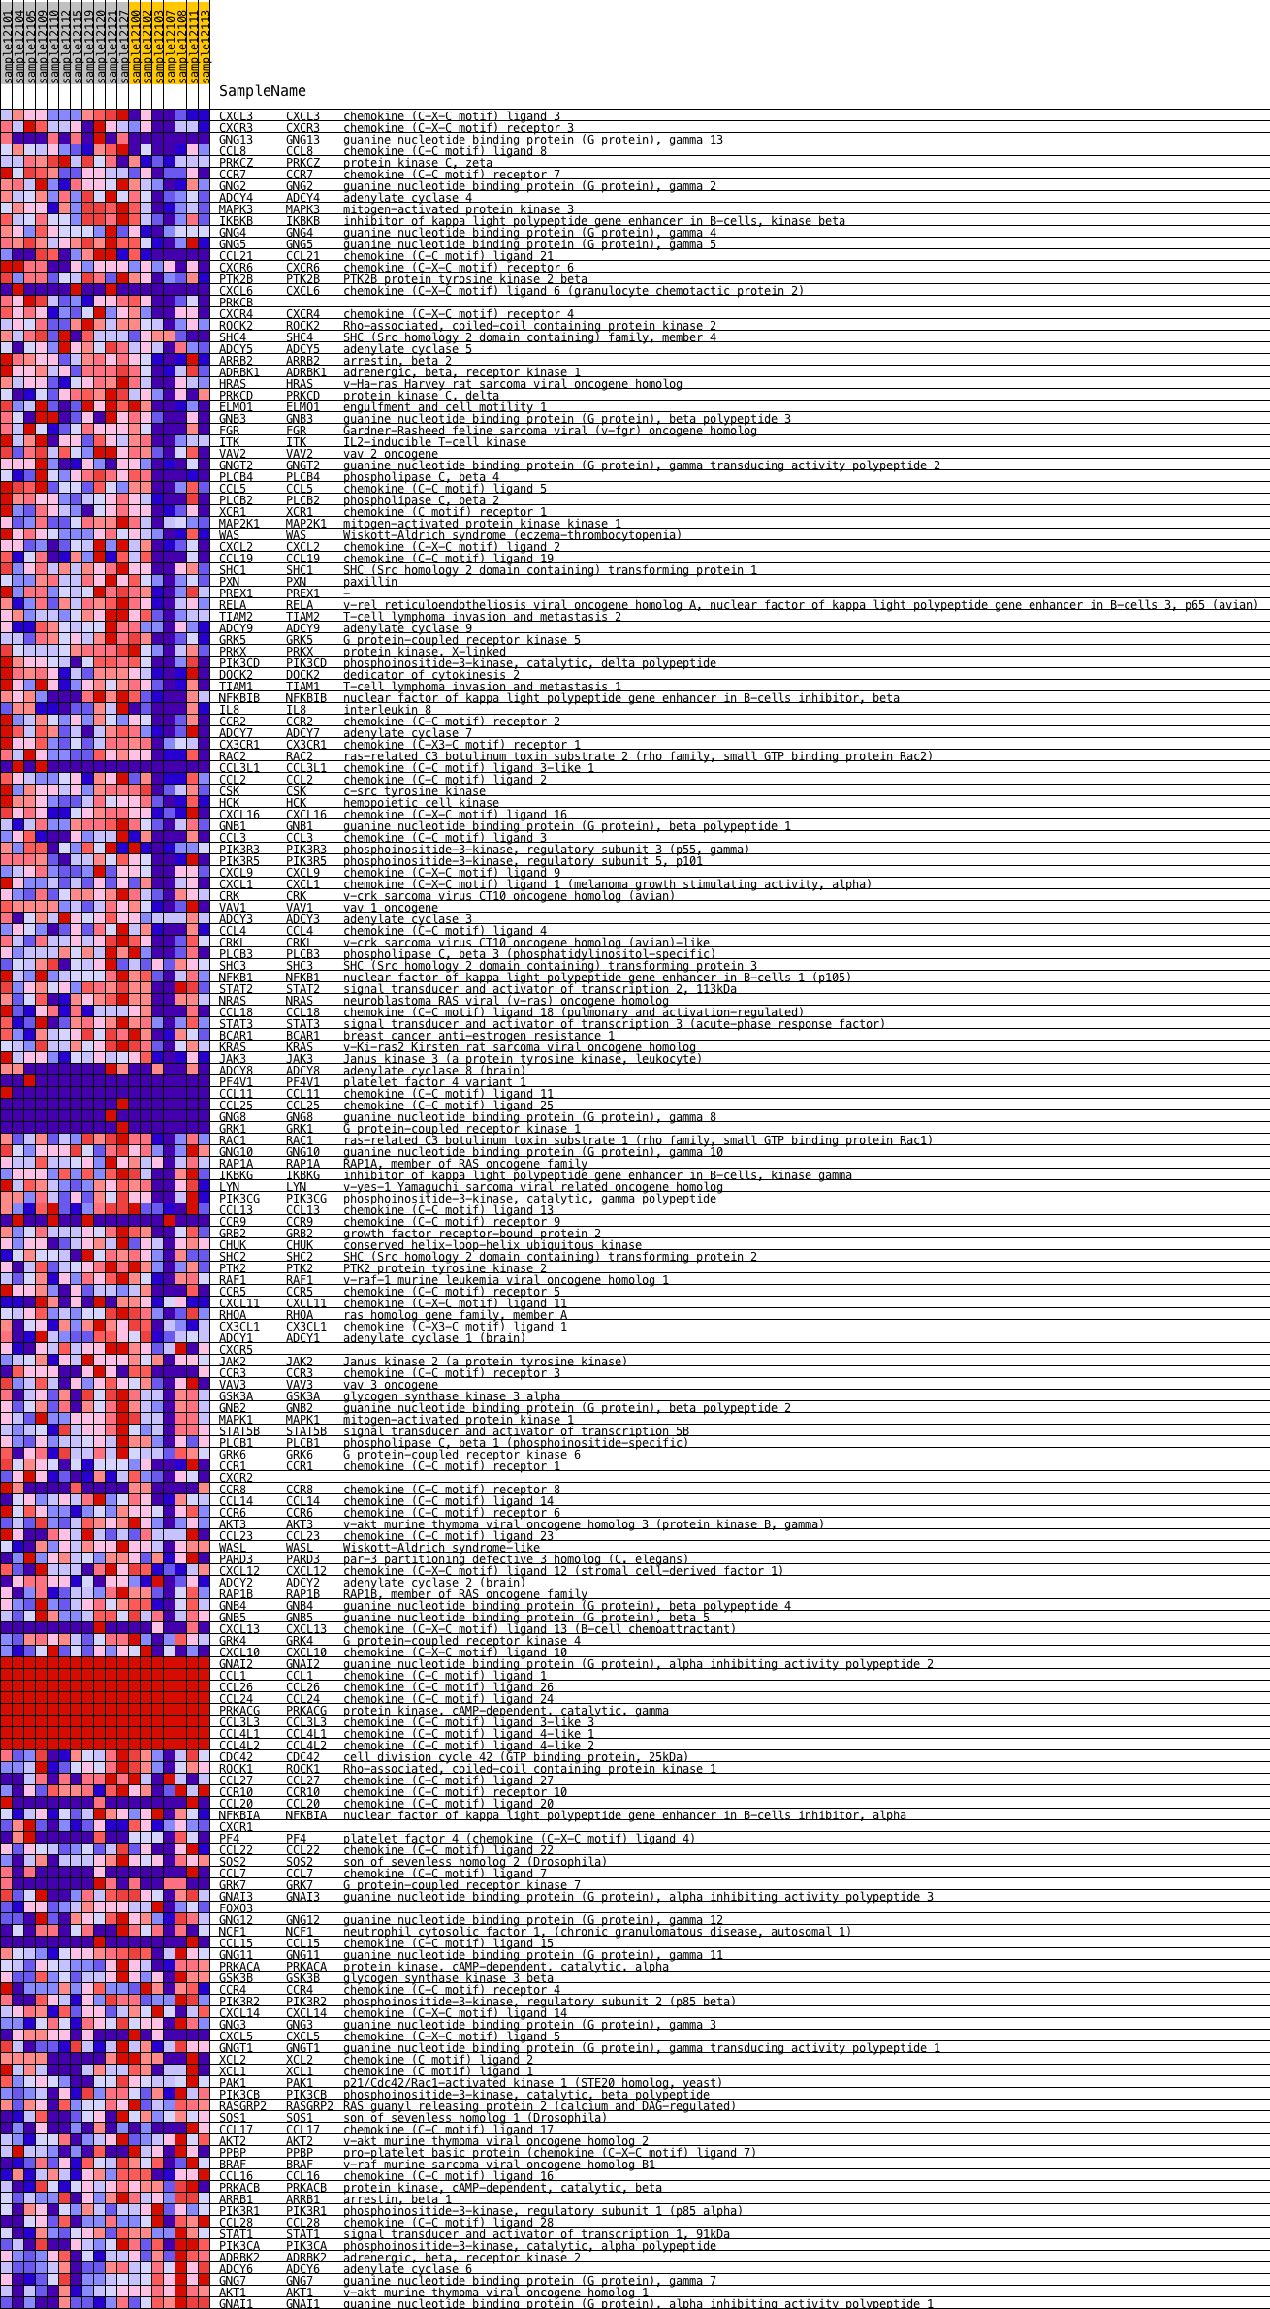

# Reactome

This is another metabolic reaction pathway, similar to KEGG

## Upregulated in Acromegaly

|  |  |  |  |  |  |
| --- | --- | --- | --- | --- | --- |
| Pathway | SIZE | ES | NES | NOM p-val | FDR q-val |
| REACTOME_CHOLESTEROL_BIOSYNTHESIS | 21 | -0.761141 | -1.8394618 | 0 | 0.10692945 |

## Downregulated in Acromegaly

|  |  |  |  |  |  |
| --- | --- | --- | --- | --- | --- |
| Pathway | SIZE | ES | NES | NOM p-val | FDR q-val |
| REACTOME_SMOOTH_MUSCLE_CONTRACTION | 24 | 0.7889705 | 1.798718 | 0 | 0.06891138 |
| REACTOME_INFLUENZA_VIRAL_RNA_TRANSCRIPTION_AND_REPLICATION | 117 | 0.55086935 | 1.6062562 | 0 | 0.2469126 |

# Transcription Factors

## Upregulated in Acromegaly

None

## Downregulated in Acromegaly

|  |  |  |  |  |  |
| --- | --- | --- | --- | --- | --- |
| Transcription Factor Binding Site | SIZE | ES | NES | NOM p-val | FDR q-val |
| V$BACH1_01 | 254 | 0.48510173 | 1.5358961 | 0 | 0.12972626 |
| V$ETS_Q4 | 245 | 0.47831804 | 1.5118655 | 0 | 0.13974182 |
| V$E47_01 | 245 | 0.49138135 | 1.5450047 | 0 | 0.17395343 |
| V$NFKB_Q6 | 252 | 0.4343454 | 1.3654791 | 0.002403846 | 0.20551328 |
| V$PPARA_02 | 125 | 0.49856678 | 1.4693131 | 0 | 0.2065532 |
| V$ELF1_Q6 | 234 | 0.4325427 | 1.3655033 | 0.006038647 | 0.21569069 |
| V$NFKAPPAB65_01 | 232 | 0.46402478 | 1.4520729 | 0.00122549 | 0.21934345 |
| V$AP1_01 | 256 | 0.439916 | 1.3899907 | 0.002450981 | 0.22141366 |
| V$NFKAPPAB_01 | 248 | 0.43439105 | 1.3668296 | 0 | 0.22310938 |
| V$SRF_01 | 50 | 0.59442925 | 1.5744017 | 0.006153846 | 0.22599924 |
| V$LBP1_Q6 | 214 | 0.4519601 | 1.3932596 | 0.003708282 | 0.22850344 |
| V$AREB6_03 | 248 | 0.43891 | 1.3822153 | 0.00365408 | 0.2305701 |
| V$TEL2_Q6 | 228 | 0.43681127 | 1.3533175 | 0.002442003 | 0.2318869 |
| V$SRF_Q5_01 | 215 | 0.443614 | 1.3675032 | 0.003667482 | 0.23302738 |
| V$ETS1_B | 249 | 0.43729487 | 1.3702782 | 0.004830918 | 0.23769614 |
| V$HEN1_01 | 188 | 0.46542367 | 1.4338672 | 0.002538071 | 0.23909368 |
| CCAWWNAAGG_V$SRF_Q4 | 86 | 0.4918713 | 1.3938532 | 0.015341702 | 0.2450895 |
| V$AP1_C | 265 | 0.43546137 | 1.3721522 | 0.002457002 | 0.24633875 |

### PPARa

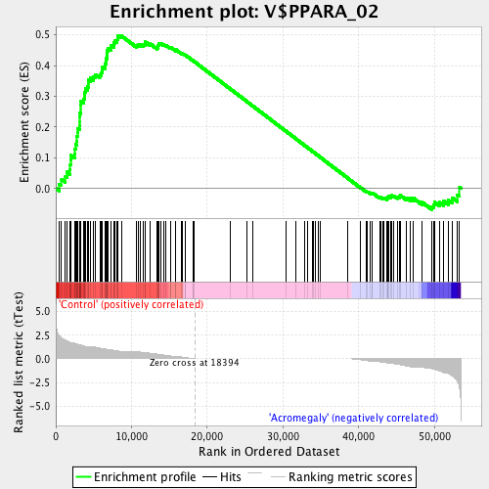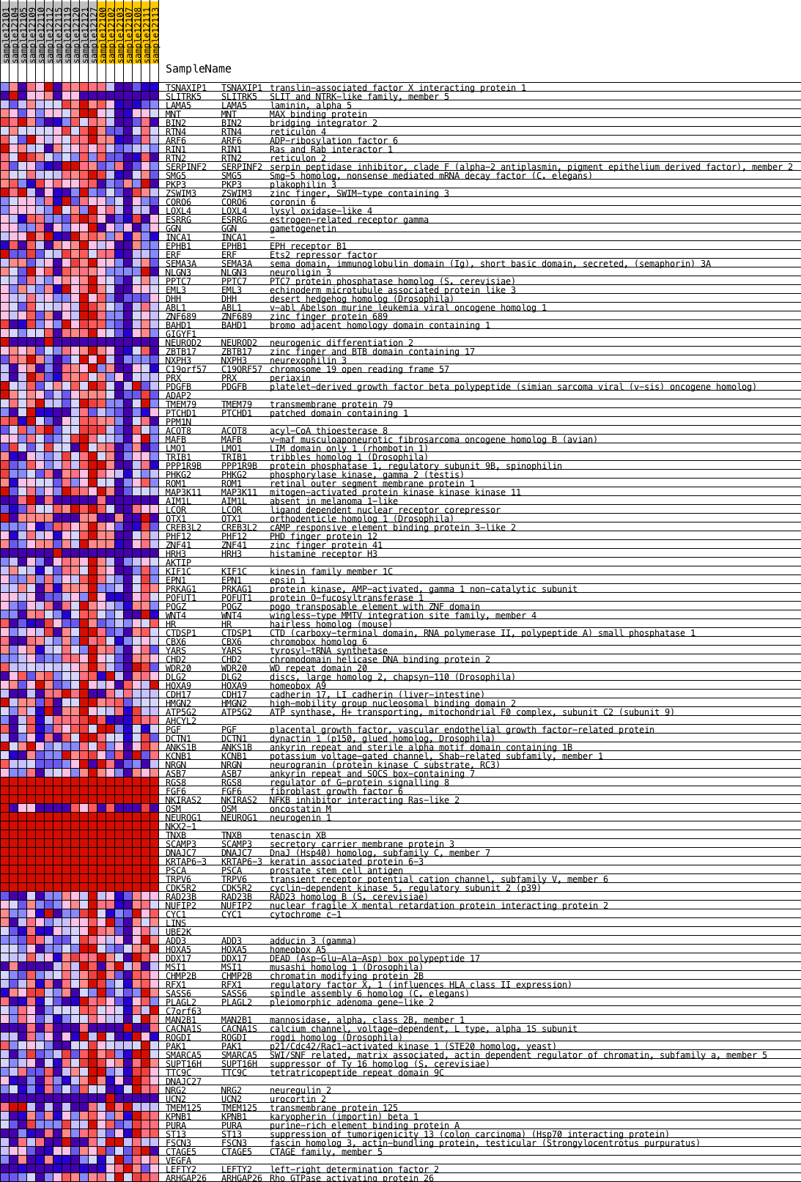

Actual PPARa expression:

Macintosh HD:Users:davebridges:Documents:Source:CushingAcromegalyStudy:figures:PPARA-barplot.pdfMacintosh HD:Users:davebridges:Documents:Source:CushingAcromegalyStudy:figures:PPARG-barplot.pdf